Design Document - JMapDesk

Short description of each Package

MapGenerator:
…/gen:
Container.java Put, Get Layers
Layer.java Obejct Layer
LayerPanel.java Panel which shows Layers
MapFile.java Predefined Mapfile
MapGen.java Main Class.
MapGen_GUI.java GUI.
WMSDialog.java Dialog to enter a WMS.

JMapDesk:
…/junit:
LayerTest.java JUnit Tests.
MapFileTest.java
MapPointTest.java

…/logic:
Map.java All needed things for generate a map.
MapTile.java Get all needed information before calling shp2img

…/mapfile:
MapFile.java Parse Mapfile.
MapFileLayer.java Mapfile Object.
TagList.java Little map parse helper

…/ui:
ErrorBox.java Shows shp2img errors in a dialog.
GUI_Components.java Some GUI things like buttons etc.
ImageToClipboard.java Put an image into Clipboard.
JMapDesk.java Main Class.
JMapDesk_GUI.java GUI.
SplashScreen.java Splash while starting.
ViewComponent.java Showing map in this window.

…/util:
MapPoint.java MapPoint Object.

…/wrapper:
InvalidBinaryException.java Throws a warning.
MapLoader.java Using shp2img to generate a map.
StreamGobbler.java Check if “shp2img” is still intact.

Detailed description of the interesting Classes

MapGenerator:
…/gen/MapGen.java
- extract_layer: filter needed data from ogrinfo.

- calc_extent: extent needs to recalculate if more than one shape is opened. To get the
whole image the smallest x, y and the largest width and height.

JMapDesk:
…/logic/MapTile.java
- load: get all data needed for shp2img

…/mapfile/MapFile.java
- readMapfile: parse mapfile line by line and retrieve needed values for further use.

…/ui/JMapDesk.java
- check_mapfile: use shp2img with “-debug 1” flag and show any warning in the errorbox.

- askForBinaryFile: if shp2img is not set in jmapdesk.cfg it will ask to point the path.

- loadMapfile: used parsed data to generate a map and update the gui.

- Innerclass SelectArea
  - Show generate map as background.
  - Override paintComponent to draw a rectangle on mousepressed and put the selected area to clipboard (not fully working at the moment!).

- ViewComponent: this window shows the generated map.

- loadMap:
  - shp2img flags:
-m specify the mapfile
-i image format
-o output path
-l just using those layers to generate a map
-e define extent
-s change mapsize

  - systemCall: use runtime to execute shp2img

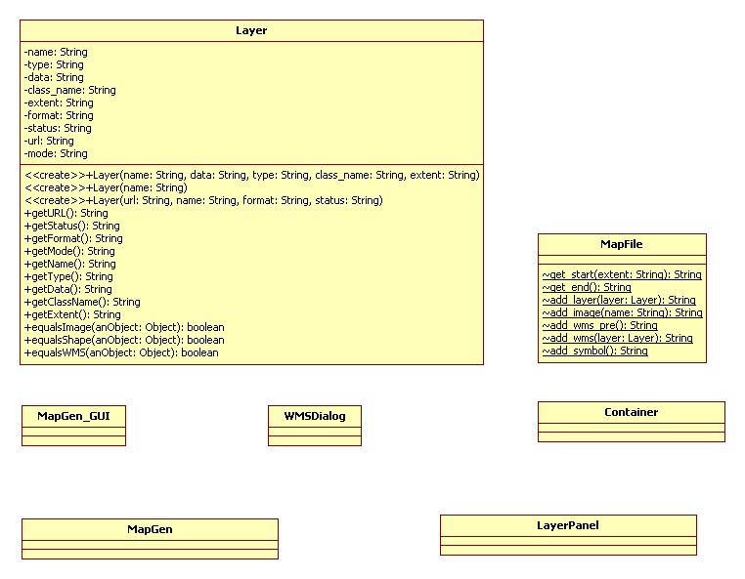
MapGenerator Overview:
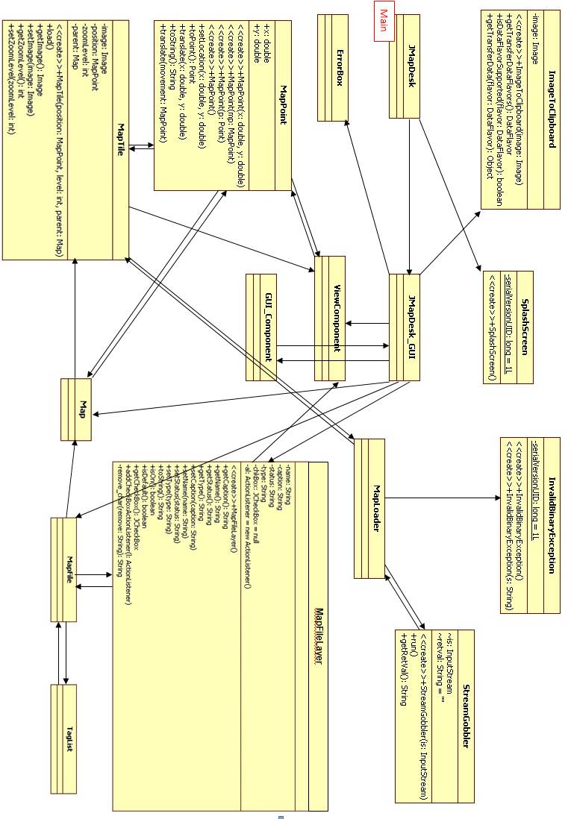
JMapDesk Overview:

